Orientation Dashboard: All Sections
Welcome Page(1):
Congratulations and Welcome to Ashoka University!
You are about to begin an incredible journey, and it all starts here. Get ready to connect, explore and grow as you prepare for success in your undergraduate journey. At Ashoka, you will find a community that inspires you to flourish and truly thrive. Let the adventure begin!

Quick Links
- Here is the updated shuttle schedule. To know how to book the shuttle, please refer to this user manual and shuttle booking guide.
- How to Reach Ashoka University.mp4
- How to Reach Ashoka University.pdf
- Recommended Laptop Configuration
- Recommended List of Hotels

You are advised to download the Ashoka mobile app using a registered Indian mobile number. Please refer to the onboarding guide for instructions on how to download and access the mobile app.
We advise you to also please help your parents to download the Ashoka Parent Mobile App. Please refer to the onboarding guide for the same here.

For additional inquiries or questions, please reach out to us via email at studentaffairs@ashoka.edu.in.

Follow us for updates: OSA Instagram handle

Updates and Upload(2):
Please follow these steps to update your details, noting that the blue text contains hyperlinks for direct access to the below mentioned sections and forms.

Please complete your profile and upload all documents

Step 1: Update Profile
- Personal & Contact Details: Enter accurate personal and contact information. Please upload a latest photograph with a white background in PNG/JPG/JPEG/GIF format under 1 MB
- Parent/Guardian Details
- Academic Qualifications
- Medical Details: Ensure accurate details in the Medical Details Form including medical history, allergies, emergency contacts, and any other relevant information for optimal support.
- Undertaking: Complete the undertaking forms.

Step 2: Upload Originals
Upload only Word, PDF, or image files, each up to 2MB in size.
2.1 Mandatory Forms/Details:
- Enter the UGC Anti-ragging reference number: Complete the Anti-ragging Affidavit form accurately with University and Course Details as instructed. Submit the form and enter the received reference number in the designated Upload Originals section.
- Download this Authorization Form for Emergency Medical & General Health and upload the filled form in the dedicated section under Upload Originals. Remember to carry a physical copy or printout of the completed form for submission at the registrar's desk on campus
- Fill out the Student and Parent Handbook Declaration Form and upload the document in the relevant section. Here is the handbook for your reference
- Fill and upload the Residence Leave Approval and Consent Form. Please read the policy carefully to make an informed choice.
Also, read the residence life policy here for your reference.
- Upload Class XII mark sheet/transcript*
- Upload Class XII certificate*
- Upload Class X mark sheet/transcript
- Upload Class X certificate
- Upload your Adhaar Card if you are an Indian National. In case you are an international student, upload your Passport
The Office of the Registrar will verify the uploaded documents with the original documents during the registration process as soon as you arrive on the campus. PLEASE CARRY YOUR ORIGINAL DOCUMENTS WITH YOU. The original documents will be returned immediately after confirming their authenticity.

* In case of any delay in receiving the original documents from your respective school or board for Class XII, please upload online results or documents from DigiLocker.

2.2 Optional:
- Enter the UGC Academic Bank of Credits (ABC) number (Submit the ABC Form, and enter the 12 digit reference number that is displayed on the ID Card generated in the designated textbox under Upload Originals section. Refer here for instructions of the process.)
- Upload Domicile certificate (for Haryana domicile students).
- Upload UG mark sheet (for transfer students).
For assistance regarding the Upload Originals section on the dashboard, please direct your inquiries to registrar@ashoka.edu.in

Important: You will find all documents, policies and handbooks in the Information and Documents section on the right side of the page.
On Arrival(3):
Registration and Check-in

To assist you in navigating the Ashoka University campus, please refer to the campus map. A virtual campus map link is also available in the quick links section for your convenience.
You can zoom in on the central campus area to locate specific residential blocks or utilize the search bar above the map to find your designated residential block. (Please ensure you are using Google Chrome, Safari, or Internet Explorer browsers to view the map, as it may not be visible on Firefox.)

Welcome to your room!!

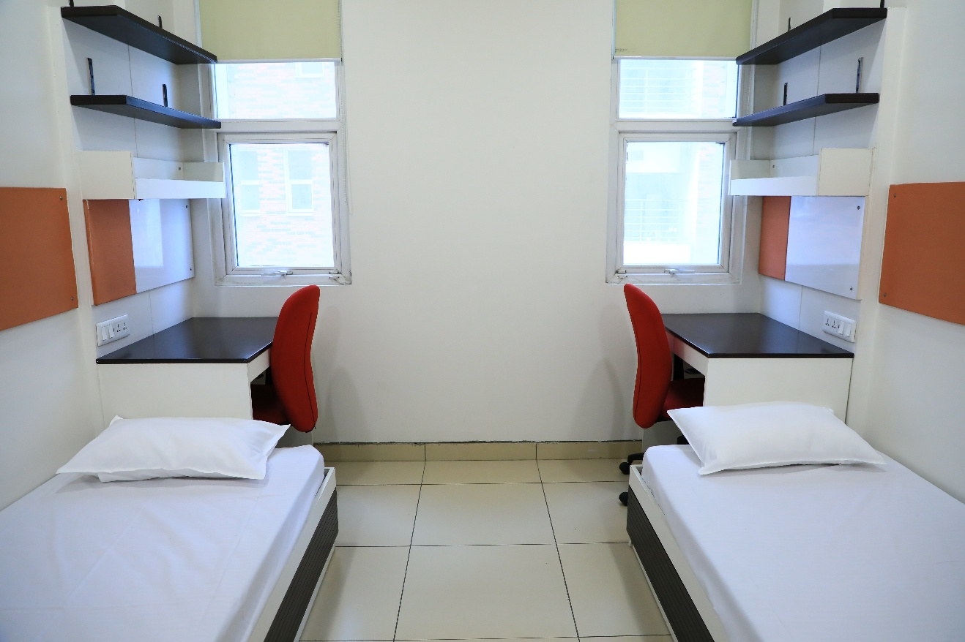

Available Room Facilities:
Each room is on twin sharing basis and features central air-conditioning, window blinds for privacy, and a nearby wastebasket with a recycling bin. Each floor of the residence halls is equipped with a pantry containing a microwave, fridge, induction plate, kettle, and water cooler for residents' convenience. Additionally, washing machines are available in all residence halls to meet students' laundry needs.
Each resident is provided with the following:
- Extra-long single bed (L80”x W38”)
- Single mattress provided
- 2 Bed Drawers
- Overhead bed light
- Wardrobe/Cupboard with a mirror inside
- Study table (desk) & chair
- White board and a soft board above the desk
- Bookshelves, attached to the wall
Check out the essential packing checklist to see what you may need.

Tips
- Buy After Arrival: Consider purchasing some items (like toiletries and stationery) from campus shops to save packing space.
Here's a list of stationery and tuckshop items.

- Pack Seasonally: Pack clothes for one season at a time to manage space and for the ease of packing during breaks (ideal for students with families living closer to the campus).
Adjust this checklist based on your personal preferences.

Happy Packing!

Orientation Week(4):
Welcoming the UG Cohort to Ashoka University's O-Week!

Our tradition of embracing new members reflects our core values: integrity, excellence, and mutual-trust. Orientation Week (O-Week) starts on Monday, 18th August, 2025, and introduces you to our culture and community spirit through a variety of mandatory activities and informative workshops. It is a crucial period to engage in our lively campus life, build connections with fellow students, and set the stage for academic achievement and personal development. Discover the opportunities of O-Week and begin an enriching experience at Ashoka University.

- Online Academic Orientation(the Zoom links are hyperlinked)
Monday, 11th August, 2025 - 6:30 to 8:00 PM - Introduction to the Office of Academic Affairs Passcode:890401
Tuesday, 12th August, 2025 - 2:00 to 3:30 PM - Introduction to Ashoka Management System (AMS) Passcode:393011
Wednesday, 13th August, 2025 - 6:30 to 8:00 PM - Introduction to Foundation Courses Passcode:050815
Thursday, 14th August, 2025 - 4:00 to 5:30 PM - Introduction to Critical Thinking | Co-Curricular Courses | Centre for Writing and Communication Passcode:862347
- Orientation Week Schedule

International Students(5):

Welcome to Ashoka University! We are delighted to have you join our diverse and dynamic community. As an international student, you bring with you a wealth of experiences, perspectives, and cultures that will enrich our campus in countless ways. At Ashoka we are committed to creating an inclusive and supportive environment where you can thrive both academically and personally. Whether this is your first time in India or you are returning, we are here to ensure that your transition is smooth and your journey fulfilling.

Recommendations for Transitioning to Campus:
- Bank account opening may take 1-6 months; plan your finances accordingly.
- It is recommended to convert the currency you are carrying to Indian currency at the airport upon arrival.
- It is advisable to carry a roaming SIM card.
- Here is a list of items you can buy at the University Tuck Shop and Stationery Shop.
- It is suggested to bring along packaged food, as it may take time to acclimate to Indian cuisine.
- Here is list of important items and their approximate cost in INR to plan your budget.
OLS(6):
The Office of Learning Support (OLS) provides comprehensive services in accessibility, academic accommodations, study skills, learning strategies, and assistive technology for students with diverse learning needs. Serving as a resource centre for disability-related information and services, OLS acts as a 360-degree support system, offering:
- Supporting students with diverse learning needs, including physical, sensory, neurological, and learning disabilities.
- Conducting screening and (in)formal assessments to identify challenges and create personalised support plans.
- Providing academic and residence-life accommodations for equal access to university activities.
- Providing career planning support to ensure equal opportunities through collaborations with the concerned offices.
- Ensuring an accessible and barrier-free campus.
- Facilitating access to assistive technology and coordinating with campus authorities to implement relevant interventions.
- Offering one-on-one coaching and mentoring for students with executive functioning difficulties.
The office promotes a neurodiversity approach, emphasising students’ unique strengths and support needs. It also promotes an inclusive campus culture through a wide variety of campaigns and events

For assistance with disabilities or other challenges during your academic journey, reach out to us anytime by writing to ols@ashoka.edu.in. Specific support services include:
- Support for Students with Disabilities
- Assistance for All Ashoka Students
- Appointment Booking Information
For more details, visit our webpage or follow us on Instagram.
ACWB(7):
The Ashoka Centre for Well-Being is a non-aligned centre offering counselling and psychological support to the students, staff, and faculty throughout their journey at the university.

With a team of professionally qualified counsellors led by Dr. Arvinder J. Singh, the Centre provides a safe space that offers free and confidential emotional support to all Ashokans. The team adopts a 360-degree approach to mental health, focusing on both curative and preventive care, promoting positive mental health practices, and fostering community building. The Centre is committed to building awareness about the value of good mental health and providing inclusive, accessible spaces for Ashokans to share their concerns, uncover their strengths, and build resilience.

Personalised Counselling Support and Crisis Interventions
We provide personalised counselling, crisis intervention, and critical emotional care to support students' mental health journeys on campus.

Reach out to us :
- Individual Counselling
You can book sessions through ACWB Portal or write to us at well.being@ashoka.edu.in to schedule an appointment. You can also speak with a counsellor by calling the ACWB Helpline at +91-7082000421, available on working days (Monday to Friday, 10 AM to 6 PM).

- 24/7 Helpline and Online Counselling Support for Immediate Assistance
24/7 Helpline for round-the-clock care
- 1800-258-8121
- 1800-258-8999
- 1800-202-6121
You can also schedule an online counselling sessison through the 1 to 1 Help Mobile App.
- Walk In Sessions for Urgent Emotional Needs
If you need to speak with a counsellor urgently, you can walk into Centre during working hours.
Location - CN313, 3rd Floor, AC04, (Library Building)
- ACWB Landline +91-130-2301198 (informational purposes only)
For more information, visit us on the website and instagram.

For further queries, ideas, or feedback, write to us at well.being@ashoka.edu.in

Student Life Clubs & Socs(8):
Find Your Tribe: Explore Clubs & Societies at Ashoka
At Ashoka University, students will find themselves immersed in pursuing their hobbies and interests through clubs and societies! These give students an ocean of opportunities to contribute and enrich their campus experience culturally and intellectually. Ranging from music, dance, and gaming to community engagement, language, creative writing, photography, culinary, and much more, students may choose from amongst the array of 42 existing clubs and societies functioning on campus, and also initiate their own!

Click here for more information.
Share your interests here, and we will help you find your space!
Watch a glimpse of events in AY 2024-2025.

Sports at Ashoka(9):
Sports@Ahoka
At Ashoka University, sports and exercise are integral to the student experience. Our approach to nurturing global citizens extends beyond the classroom and into our state-of-the-art sports facilities, where students are encouraged to push their boundaries and discover their potential. This journey fosters self-awareness, discipline, and transformation, preparing students to create meaningful change within themselves and their world.
Click here for more information.
Fill out this Interest form.
Student Care(10):
Student Care at Ashoka
Who We Are
We are non-clinical case managers eager to engage students as they navigate their social, emotional, physical, and relational wellness at Ashoka. Our team assists students along the way at Ashoka: particularizing care and support, providing referrals to campus partners, creating accountability and growth opportunities.
What We Offer
At Ashoka University, we strive to support students' overall wellbeing through Student Care. This encompasses non clinical case management dedicated to students experiencing academic, relational, emotional, physical, or mental health-related distress, grounded in compassion, support, and personal development. Additionally, we offer support and, when necessary, compassionate discipline to those who violate the community standards outlined in the student handbook. In all situations, we strive to support students from a developmental and community-focused perspective.
Compassionate Community
We believe in fostering a supportive and compassionate community where every individual feels valued and understood. Addressing mental health is a vital part of student success at Ashoka. We encourage students to help de-stigmatize mental health by embracing open conversations about emotional wellbeing and recognizing that seeking help is a sign of strength, not weakness. Just as we care for our physical health, taking care of our mental health is essential for personal growth and academic success. By supporting one another and breaking down the barriers around mental health, we can create an environment where everyone can thrive. The Student Care Office provides dedicated case managers who will champion all students’ health and whole-person wellness.
Contact Student Care Office:
• Email at studentcare@ashoka.edu.in for support or to report a concern
• Helpline Number : 7082000403
People:
Ms. Anuradha Sen
Email: anuradha.sen@ashoka.edu.in, studentcare@ashoka.edu.in
Office Location: RH2, Ground Floor
FAQs(11):
Shared

